AVOIDING REAR END COLLISIONS

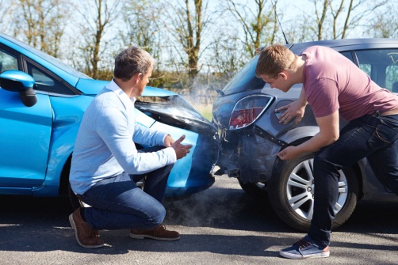

TO AVOID REAR END COLLISIONS

MAINTAIN AT LEAST A FOUR SECOND FOLLOWING DISTANCE

AND LEAVE YOURSELF AN OUT

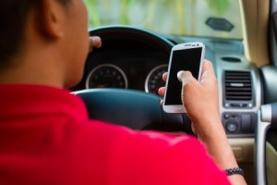

PLEASE REMEMBER TO KEEP YOUR EYES ON THE ROAD IN FRONT OF YOU

AND PUT YOUR CELL PHONE AWAY

Drivers talking on cell phones are nearly twice as likely as other drivers involved in crashes to have

rear end collisions, according to a University of North Carolina at Chapel Hill study.

**SAFETY TIP:** STAYING HYDRATED WILL HELP KEEP YOU MORE ALERT ON THE ROAD AND ON THE ROUTE.