ROAD RAGE DISCUSSION

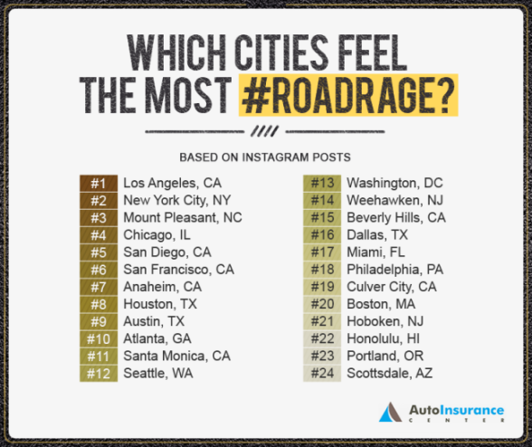

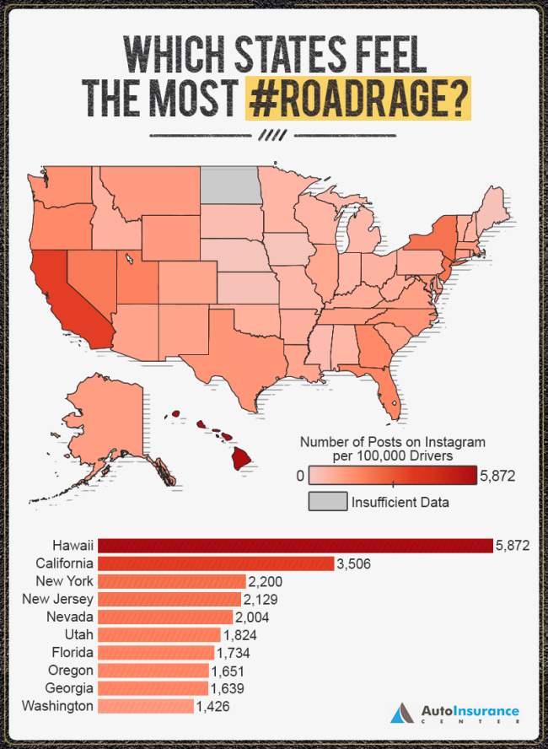

DID YOU KNOW THAT THERE IS SOMETHING YOU CAN DO IF YOU ARE WITNESSING ROAD RAGE WHILE ON YOUR ROUTE? THE OREGON DMV STATES THAT CALLING **911** TO REPORT ROAD RAGE IS ACCEPTABLE WHEN YOU ARE DRIVING WITHIN CITY LIMITS.

COMMON ROAD RAGE BEHAVIORS

* Tailgating
* Flashing Lights
* Hand Gestures
* Yelling
* Foul Language
* Frequent Lane Changes
* Refusing to Signal