TRUSTED INVESTMENTS, INC. & TI 2, INC. SAFETY FOCUS

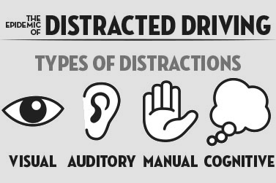

**Visual distractions:** Anything that takes your eyes off the road

**Cognitive distractions:** Anything that takes your mind off the road

**Manual distractions:** Anything that takes your hands off the wheel

**Auditory distractions:** Hearing something not related to driving

(INFORMATION COURTESY OF OREGON DEPARTMENT OF TRANSPORTATION)

**Ditch the distractions**

1. **Set up a hands free device.** Set up a hands free device for your phone before you head out to the route.
2. **Spread the word.** Record a message on your phone that tells callers you're driving and will get back to them when you're off the road.
3. **Pull over.** If you need to make a call, pull over to a safe area first.
4. **X the text.** Don't ever text and drive, browse online or read your email while driving. It's dangerous and against the law in most states. Even voice-to-text isn't risk-free.
5. **Know the law.** Familiarize yourself with state and local laws before you get in the vehicle. Oregon prohibits the use of hand-held cell phones in addition to texting.
6. **Prepare.** If using a GPS device, enter your destination before you start to drive. Review your turn by turn or map in advance.
7. **Focus on driving.** Multi-tasking behind the wheel is dangerous. Refrain from reading, grooming, smoking, and any other activity that takes your mind and eyes off the road.