*THE GOOD JUDGMENT/SAFETY CONNECTION*

|  |
| --- |
| Taking the time to think through the possible outcomes of a parking choice can prevent a tow truck scenario. |

|  |
| --- |
| Taking the time to think through where you leave the package can prevent a theft. |

|  |
| --- |
| Taking the time to make a phone call for assistance in finding an address can prevent a delivery dispute. |

|  |
| --- |
| Taking the time to remove garbage from your truck can prevent germs that lead to missed days. |

|  |
| --- |
| Taking the time to properly load your truck can cause your deliveries to go more quickly and smoothly. |

|  |
| --- |
| Taking the time to pull off and let someone pass in a tight spot can prevent an accident. |

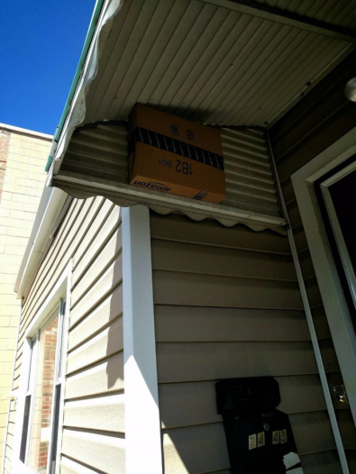

“WHEN THE DELIVERY DRIVER KNOWS THE NEIGHBORHOOD”