THERE IS NO SAFETY IN NUMBERS

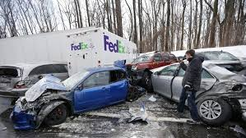

ISOLATE YOURSELF

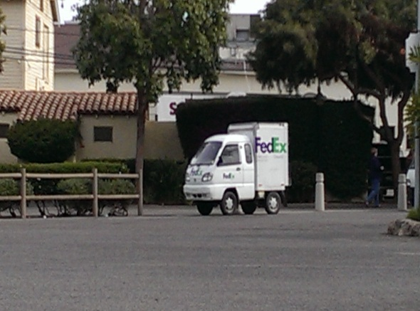

REMAIN INDEPENDENT

NOTES:______________________________________________________________________________________________________________________________________________________________________________________________________________________________________________________________________________________________________________________________________________________________________________________________________