MAINTAIN A FULL CAR LENGTH OF CUSHION WHEN STOPPED

NOTES:__________________________________________________________________________________________________________________________________________________________________________________________________________________________________________________________________________________________________________________________________________________________________________________________________________________________________________________

YOU CAN PREVENT HITTING SOMEONE IN FRONT OF YOU

IF YOU ARE HIT FROM BEHIND

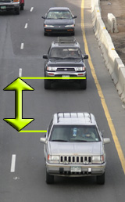

CREATE SPACE FOR BETTER VISIBLITY