AVOID HITTING RED LIGHTS WHEN POSSIBLE

|  |  |
| --- | --- |
| WHY | HOW |
| To reduce your chance of a rear end collision | Observe traffic patterns |
| To save wear and tear on brakes and transmission | Assess pack density |
| To reduce fuel consumption | Anticipate brake lights over the hill or around the corner |
|  | Pace the lights to keep your vehicle moving and your space cushion intact |

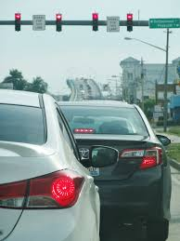

NOTES:________________________________________________________________________________________________________________________________________________________________________________________________________________________________________________________________________________________________________________________________________________________________________________________________________________________________________________________________________