KEEP GOOD COMPANY ON THE ROAD BY MANAGING TAILGATERS

 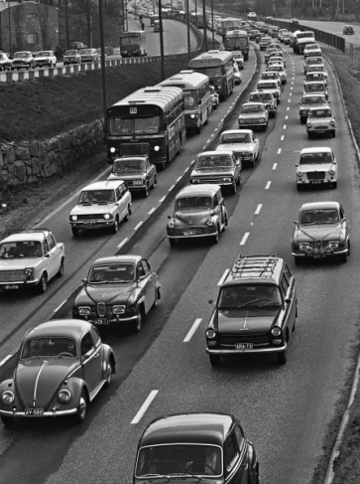

3 Types of Tailgaters:

1. Habitual Tailgaters
2. Followers
3. Message Senders

*Tailgaters distract us by taking our eyes off the road ahead,*

*changing our pattern*

*of mirror-checking, and*

*making driving overly emotional.*