CHECK MIRRORS EVERY 5-8 SECONDS

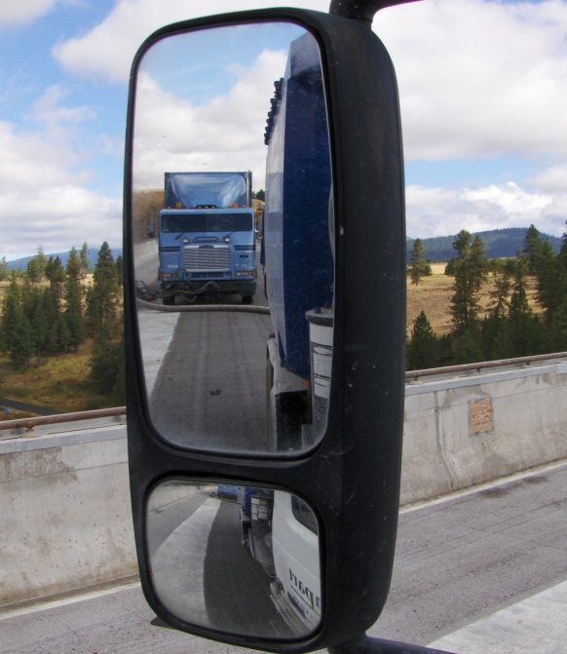

FORM A PATTERN OF MIRROR CHECKING

Left Side Rear View Right Side

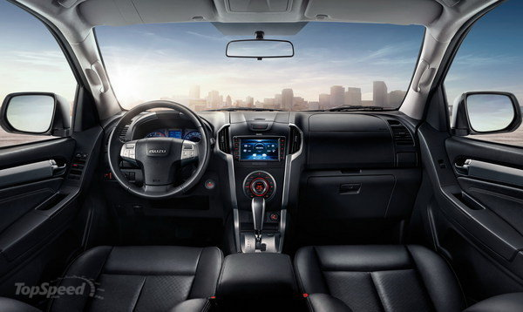

A study by the University of Texas’ Department of Electrical Engineering found that drivers who engage in secondary activities while driving check their mirrors less often than those who do not.